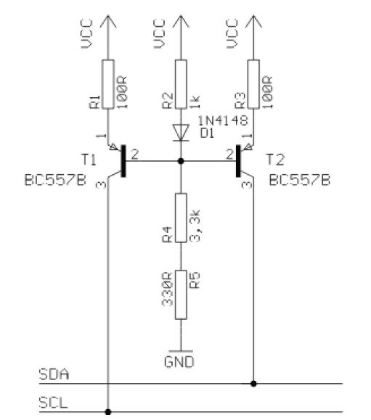

1N4148 0,6 V drop

5 – 0,6 = 4,4 V > 1K : 3,63K = 0,95 V : 3,44 V (= U basis)

|  |  |
| --- | --- |
| BC557B / BC560C PNP  Geel Vcc  Groen Serial-CLock SX A5  Rood Serial-Data SY A4  Zwart Gnd  22uF Vcc-line buffer !!  Reed relais in serie  500 ohm = 10 mA  100 ohm + 2 x reed relais parallel = 15 mA |  |

The following information was submitted by Detlef Queck.

Many people have problems over and over with I2C(TWI) Termination. Use 4,7k or 10 k pull up? How long can the SCL, SDA line be when used with pull ups etc, etc.

You can simplify this confusing problem. Here is a Schematic for an active Termination of I2C and TWI. We have used this Schematic for over 10 years, and have had no

problems with it. The I2C (TWI) lines can be up to 80cm (400KHz) without any problem when the Terminator is at the end of the lines.

<http://avrhelp.mcselec.com/index.html?using_the_i2c_protocol.htm>

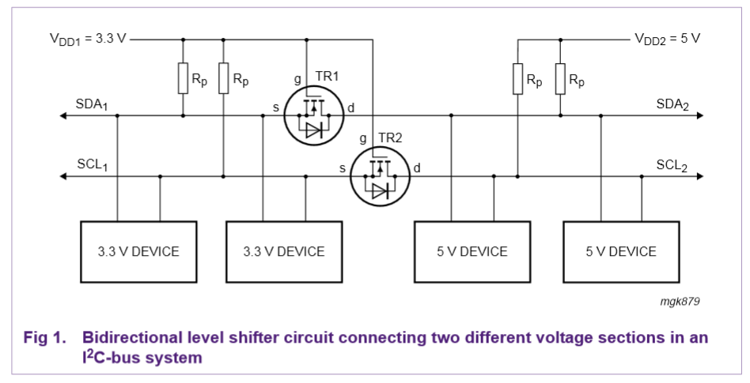

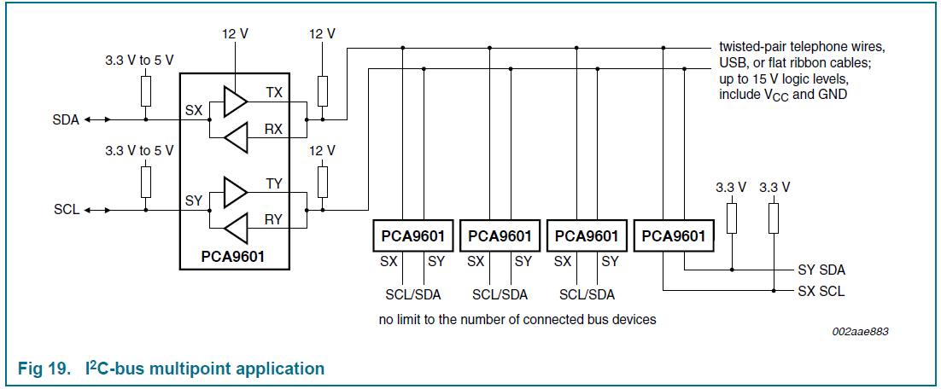

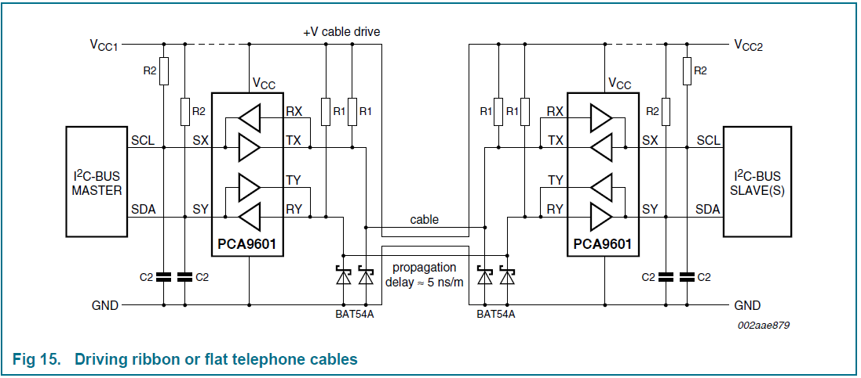

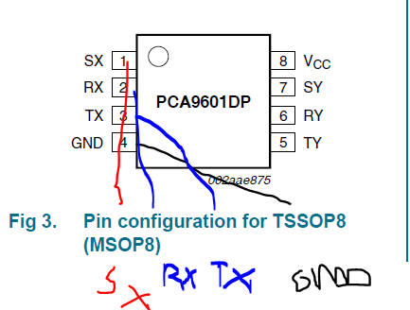

Geel Vcc

Groen Serial-CLock SX A5

Rood Serial-Data SY A4

Zwart Gnd